0 Ω
0 Ω | 1 Ω | 1.2 Ω | 1.5 Ω
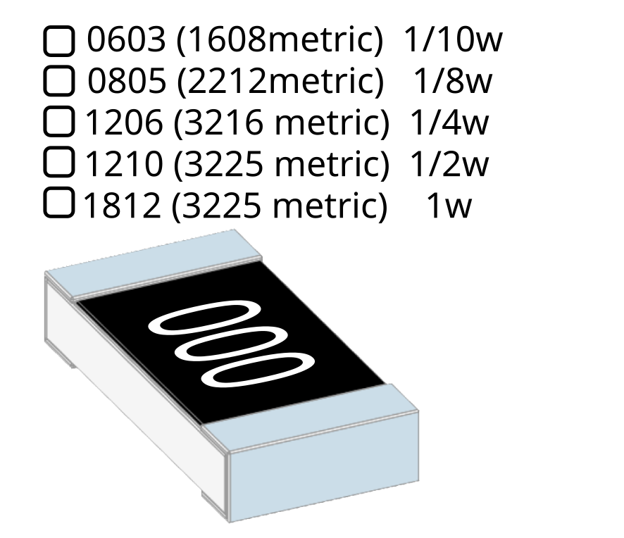
1.8 Ω | 2.2 Ω | 2.7 Ω | 3,3 Ω
3.9 Ω | 4.7 Ω | 5.1 Ω | 5.6 Ω
6.8 Ω | 8.2 Ω | Ω | Ω

10 Ω
10 Ω | 12 Ω | 15 Ω | 18 Ω
22 Ω | 27 Ω | 33 Ω | 39 Ω
47 Ω | 51 Ω | 56 Ω | 68 Ω
82 Ω | Ω | Ω | Ω
100 Ω
100 Ω | 120 Ω | 150 Ω | 180 Ω
220 Ω | 270 Ω | 330 Ω | 470 Ω
510 Ω | 560 Ω | 680 Ω | 820 Ω
820 Ω | Ω | Ω | Ω

1 KΩ
1 KΩ | 1.2 KΩ | 1.5 KΩ | 1.8 KΩ
2.2 KΩ | 2.7 KΩ | 3.3 KΩ | 3.9 KΩ
4.7 KΩ | 5.1 KΩ | 5.6 KΩ | 6.8 KΩ
8.2 KΩ | Ω | Ω | Ω

10 KΩ
10 KΩ | 12 KΩ | 15 KΩ | 18 KΩ
22 KΩ | 27 KΩ | 33 KΩ | 39 KΩ
47 KΩ | 51 KΩ | 56 KΩ | 68 KΩ
82 KΩ | Ω | Ω | Ω

100 KΩ
100 KΩ | 120 KΩ | 150 KΩ | 180 KΩ
220 KΩ | 270 KΩ | 330 KΩ | 390 KΩ
470 KΩ | 510 KΩ | 560 KΩ | 680 KΩ
820 KΩ | Ω | Ω | Ω

1 MΩ
1 MΩ | 1.2 MΩ | 1.5 MΩ | 1.8 MΩ
2.2 MΩ | 2.7 MΩ | 3.3 MΩ | 3.9 MΩ
4.7 MΩ | 5.1 MΩ | 5.6 MΩ | 6.8 MΩ
8.2 MΩ | 10 MΩ | Ω | Ω

